COMPONENTS OF FITNESS:

* MUSCULAR ENDURANCE & STRENGTH
* BODY COMPOSITION
* FLEXIBILITY
* CARDIORESPIRATORY ENDURANCE

**Etiquette:**

**Do:**

Roll the ball UNDER the net to the serving team

Call out “Mine” to show your intent to play the ball.

Be a team player.

**Don’t:**

Kick the volleyball

Touch or grab the net.

“Hog” the ball!

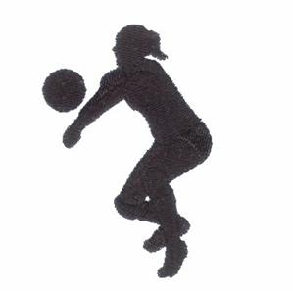

**Volleyball Court**

**Attack line:** A line 10 feet from the net; separates each side of the court into front and back zones; often called the 10-foot line

**Center line:** Divides the court into two areas; the net is placed above the center line.

**End line:** Back boundary at each end of the court.

**Sideline:** Side boundary at each side of the court.

[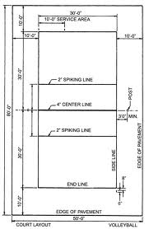](http://www.google.com/imgres?q=volleyball+court&hl=en&safe=active&biw=1366&bih=587&gbv=2&tbm=isch&tbnid=H-6shZobQnRqBM:&imgrefurl=http://www.constructionwork.com/resources_details_1278volleyball_court_layout_with_net_detail.html&docid=K4IoIeeYxhwjJM&imgurl=http://www.constructionwork.com/images/VolleyballCourta.jpg&w=700&h=1075&ei=1zc9T5yEF4LZiQLRpaS7AQ&zoom=1)

**Description**

Volleyball is played with 2 teams of 6 players each. The game begins when one team serves volleyball over the net to the other team. The game continues as each team returns the ball over the net to the opponent and ends when one team reaches the required number of points and is declared the winner.

**Sportsmanship**

* Sportsmanship means showing respect for your team and the opposing team.
* Following rules.
* Accepting outcomes without arguing, giving up or gloating.
* Cheering for your team and applauding your opponent’s good performance.

**Perseverance** is shown in sportsmanship by continuing to show respect and play hard even if you are disappointed by your, or your team’s performance. Perseverance means accepting decisions and outcomes even if you do not agree with them or are not happy about them. Lastly, it means to cheer for your team when they are not playing well, whether you are a player or a spectator.

[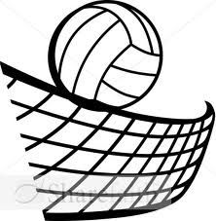](http://www.google.com/imgres?q=volleyball&hl=en&safe=active&biw=1366&bih=587&gbv=2&tbm=isch&tbnid=F_J5GEcjPjMW-M:&imgrefurl=http://www.faithclipart.com/image/volleyball-in-black-and-white.html&docid=nslVwdzjMY8nZM&imgurl=http://images.faithclipart.com/images/3/1211221447444_26/img_large_watermarked.jpg&w=378&h=388&ei=Bwk8T7yqDKnYiALMhPGTDA&zoom=1)

**Volleyball**

1. *How many players are on the court at one time? How many players on each team? ________*

________________________.

1. *Give an example of how you can demonstrate* ***sportsmanship.***

*_____________________________*

*____________________________.*

1. *How can you demonstrate perseverance when playing volleyball? ________________*

*____________________________.*

1. *Which of the following is* ***NOT*** *an example of proper etiquette in volleyball?*
   1. *Roll the ball UNDER the net.*
   2. *Kick the volleyball*
   3. *Call out “MINE” to show your intent to play the ball.*
   4. *Be a TEAM player.*
2. *When* ***spiking*** *the ball from the* ***BACK*** *court, you cannot pass which line on the court?*
   1. *10-foot line or Attack Line*
   2. *Center Line*
   3. *Side Line*
   4. *End Line*
3. *At which line is the NET placed?*

*_________________________.*

1. *What types of strength and endurance exercises can help your performance in volleyball?*

*________________________*

*________________________*

*________________________*

*________________________.*

# ANSWER THE QUESTIONS BELOW

### PHYSICAL EDUCATION

**Biomechanics Vocabulary**

1. **Biomechanics:** The study of forces and their effects on human movement.
2. **Body segment:** A body part between joints; the forearm is a body segment between the wrist and elbow joints.
3. **Radius of Rotation:** The distance from the center of rotation to the point of contact. (A straight arm has a longer radius of rotation than a bent arm).
4. **Range of Motion:** The distance through which a body segment moves at a joint.

[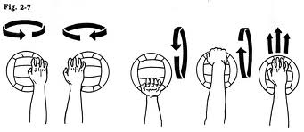](http://www.google.com/imgres?q=spin+in+volleyball+serve&hl=en&gbv=2&biw=1366&bih=599&tbm=isch&tbnid=qjpqQ-UQ0SP1SM:&imgrefurl=http://www.austinvolleyball.com/articles.cfm%3Fview%3Darticle%26id%3D52&docid=Yps7O4_-undtKM&imgurl=http://www.austinvolleyball.com/images/serve2-6.jpg&w=2029&h=881&ei=zBxBT4Iag9GIApT4gLYB&zoom=1)

**Factors affecting FORCE:**

* The FORCE resulting from contracting arm muscles is transmitted to the volleyball during a serve and causes the ball to travel over the net.
* The greater the SPEED, the greater the FORCE.
* The greater the RANGE of MOTION, the greater the FORCE.
* The more BODY SEGMENTS involved, the greater the FORCE.
* The longer the RADIUS OF ROTATION, the greater the FORCE.

## BIOMECHANICAL PRINCIPALS

**The serving team scores a point when:**

A player on the team hits the ball to the floor, in bounds, in the opponent’s court.

The opposing team fails to return the ball.

**To win the game:**

Your team must score 15 points and win by 2.

**To win the match:**

You must win 2 out of 3 games.

**Rules of the Game**

**When a team gets the serve:**

Everyone on the team must rotate one position clockwise before the serve.

**Before the ball is served:**

All players on both sides of the court must be in position.

**Serve goes to the other team if:**

The ball hits the net, ceiling or other obstruction on the serve.

The serve lands out of bounds.

The server steps on the line when serving.

A player on the serving team touches the ball before the serve goes over the net.

[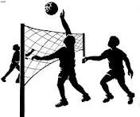](http://www.google.com/imgres?q=volleyball&hl=en&biw=1366&bih=599&gbv=2&tbm=isch&tbnid=BeKiFIk6PaASbM:&imgrefurl=http://www.akron-westfield.k12.ia.us/images/MS%2520Athletics/Volleyball/&docid=2-76sjQ3QrZW3M&imgurl=http://www.akron-westfield.k12.ia.us/images/MS%252520Athletics/Volleyball/volleyball.gif&w=800&h=669&ei=fxVBT-OEKa_YiQLn6ai5AQ&zoom=1&iact=rc&dur=109&sig=110245770306737817439&page=3&tbnh=120&tbnw=144&start=58&ndsp=32&ved=0CNECEK0DMD4&tx=72&ty=61)

**When playing the ball:**

* A team may contact the ball no more than 3 times before returning it.
* A player may not contact the ball twice in a row.
* A block does NOT count as a contact.
* You can legally contact the ball with any body part above and including the waist.
* You may NOT touch the net.
* Back row players cannot spike the ball in front of the attack line or block the ball.

* Cover your assigned area on the court.
* Attempt to get any ball in your area.
* Call “mine” as soon as you know you are taking the ball.
* Call “open” and turn sideways if you are unable to take a ball.

**Front Row: LF, CF, RF**

**Back Row: LB, CB, RB**

**Server:** Right back

**Setter:** Receives a pass from a team member and sets the ball for the spiker.

**Spiker:** Any front-row player or any back row player behind the attack line.

**ROTATION:** Clockwise

**Ace:** A serve that results directly in a point.

**Assist**: A pass or set of the ball to a teammate who spikes or tips the ball for a kill.

**Block**: A defensive action in which one or more players stop a ball before, or just after, it crosses the net.

**Contact:** Any touch of the ball by any part of a player (except hair).

**Dig:** Reception of a ball that has been spiked, usually using a lower forearm pass position.

**Double hit:** Contact of a ball by any player two consecutive times.

**Fault:** An error that results in a loss of serve or a point awarded to the other team.

**Free ball:** A ball returned by a pass rather than a spike or tip.

**Kill:** A spike that results in an immediate point or side out.

**Lift:** An illegal contact in which the ball is held momentarily in the hand or hands.

**Opening up:** Turning sideways to face the player who is playing the ball.

**Rotation:** Movement of players one position clockwise before their team serves.

**Side out:** A swerve that goes to the other team because the serving team did not score.

**Tip or dink:** A ball passed over the net with an overhead pass.



**Game Play**

Six (6) players on each team include:

[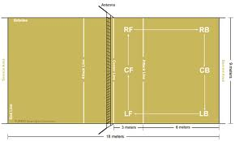](http://www.google.com/imgres?q=volleyball+court+diagram+with+positions&um=1&hl=en&safe=active&gbv=2&biw=1366&bih=587&tbm=isch&tbnid=a0TW_jELWdXUZM:&imgrefurl=http://www.sportspectator.com/fancentral/volleyball/guide03.html&docid=PZrSg75a7pm-2M&imgurl=http://www.sportspectator.com/fancentral/volleyball/Volleyball_Diagram.gif&w=590&h=354&ei=2W09T-HBNYPYiQL2nYylAQ&zoom=1&iact=rc&dur=0&sig=116418743795880283409&page=1&tbnh=92&tbnw=153&start=0&ndsp=21&ved=0CEMQrQMwAA&tx=133&ty=60)

*8. What direction do the players move when* ***rotating*** *before the next serve?*

a. *Clockwise*

*b. Counterclockwise*

*c. Forward*

*d. Backward*

*9. What does* ***“opening up”*** *mean? ________________*

*_____________________.*

*10. What is the* ***defensive*** *action called in which one or more players stop a ball before, or just after, it crosses the net?__________*

*11. List 2 ways in which the serve goes to the other team:*

*a. ___________________*

*______________________*

*b. ____________________*

*_____________________.*

*12. How many times can the team contact the ball?______*

*13. TRUE or FALSE:*

*A player can contact the ball twice in one turn.*

*14. TRUE or FALSE:*

*You can legally contact the ball with any body part above and including the waist.*

*15. How many points to win the game? _____________.*

*16. Biomechanics is the study of _____________ and their effects on __________*

*___________________.*

*17. The greater the SPEED, the greater the _________.*

*18. The more _________*

*_____________ involved, the greater the FORCE.*

*19. When FORCE is applied to the middle of the ball, will it spin? YES or NO.*

*20. What type of spin will occur if the force is applied to the TOP of the ball?__________*

*BOTTOM?___________*

## VOCABULARY