C:\Documents and Settings\stacee-oltmanns\Local Settings\Temporary Internet Files\Content.IE5\7G2AS69R\MC900292486[1].wmf

**Physical Education Department Staff**

[Stacee-Oltmanns@SCUSD.EDU](mailto:Stacee-Oltmanns@SCUSD.EDU)

[Kelli-White@SCUSD.EDU](mailto:Kelli-White@SCUSD.EDU)

[Jay-Blockmon@SCUSD.EDU](mailto:Jay-Blockmon@SCUSD.EDU)

[Gary-Kretzschmar@SCUSD.EDU](mailto:Gary-Kretzschmar@SCUSD.EDU)

(916) 228-5800 EXT 1620 or 1610

Quality physical education programs are needed to increase the physical competence, health-related fitness, self-responsibility and enjoyment of physical activity for all students so that they can be physically active for a lifetime. Physical education programs can only provide these benefits if they are well-planned and well-implemented.

**Below are some resources for you:**

<http://www.cahperd.org/toolkit.html>

This website offers a variety of topics for you to explore such as:

* What does a quality Physical Education program look like?
* What is the difference between physical activity and Physical Education?
* Physical Education is an academic subject.
* Why do children need Physical Education

<http://www.aahperd.org/naspe/about/relatedLinks/parents.cfm>

This website is NASPE’s Parent Resource page. Most questions can be answered via this website.

<http://www.cde.ca.gov/ci/pe/>

This website will show you the content standards for the state of CA. This is what your student should be learning in Physical Education.

### Parent, family, and community resources

Tel: 916-228-5800

9325 Mirandy Dr.

Sacramento, CA 95826

[www.einsteinmiddleschool.org](http://www.einsteinmiddleschool.org)

[www.facebook.com/Alberteinsteinmiddleschool](http://www.facebook.com/Alberteinsteinmiddleschool)

# Albert Einstein Middle School

## Physical Education

# Albert Einstein Middle School



**Physical Education Department Mission:** To design and teach a well-balanced standards-based curriculum providing differentiated, culturally responsible and equitable instruction so ALL students develop an acceptable level of fitness with a broad spectrum of physical skills to keep them active for a lifetime.

**Objectives:**

* The students will be able to demonstrate knowledge of and competency in motor skills, movement patterns, and strategies needed to perform a variety of physical activities.
* The students will achieve a level of physical fitness for health and performance while demonstrating knowledge of fitness concepts, principles, and strategies.
* The students will demonstrate knowledge of psychological and sociological concepts, principles, and strategies that apply to the learning and performing of physical activity.

### Physical Education

#### Safe and Positive Learning Environment

**Expectations:**

* **R**esponsibility
* **E**ffort
* **S**elf-Control
* **P**erseverance
* **E**xemplaryLeadership
* **C**ompassion
* **T**eamwork

We practice these social skills by engaging in cooperative activities such as group skiis, human knots, and other challenges that encourage the group to work together to problem solve.

#### Units of Study:

* Fitness
  + Body Sculpting
  + Weight Training
  + Aerobics
  + Kickboxing

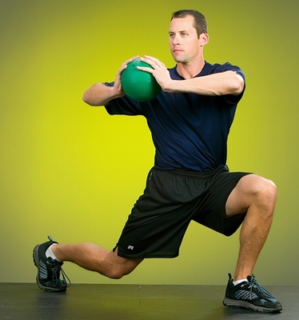

* Dance
* Tumbling (gymnastics)
* Individual and Dual
  + Pickleball
  + Badminton
  + Juggling
  + Disc Golf
  + Orienteering
* Team Sport
  + Basketball
  + Team Handball
  + Ultimate Frisbee
  + Volleyball
  + Football
  + Rugby
  + Soccer
  + Flicker ball