Answer the questions below: | ESTABLISHING A POSITIVE LEARNING ENVIRONMENT
1. What does RESPONSIBILITY mean to you?  2. Why would putting forth EFFORT help your grade?  3. How do you demonstrate SELF-CONTROL at school?  4. When you get frustrated, what do you do to keep going and not give up?  5. What would an EXEMPLARY LEADER in P.E. do?  6. How will you demonstrate COMPASSION this year in P.E.?  7. Where do you use teamwork & why is it important to P.E. & life?  8. What model is used in P.E. for rules & expectations?  9. What does “R” stand for and what activity focused on that word?  10. What does “E” stand for and what activity focused on that word?  11. What does “S” stand for and what activity focused on that word?  12. What does “P” stand for and what activity focused on that word?  13. What does “E” stand for and what activity focused on that word?  14. What does “C” stand for and what activity focused on that word?  15. What does “T” stand for and what activity focused on that word?  16. How can you earn an A in P.E.? | 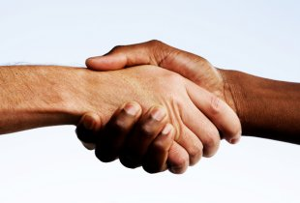  A handshake can mean so many things. You use them when you meet someone, congratulate, or are just passing someone in the halls to acknowledge them. When you receive a handshake, the RESPONSIBLE thing to do is return the handshake with a strong and firm grip. Responsibility is when you own your actions, are accountable, and reliable. Even when you don’t feel like it. During the “Partner Handshake” activity, accept personal responsibility to create and maintain a physically and emotionally safe and non-threatening environment for physical activity. In Physical education, there are many ways to demonstrate responsibility. Dress every day, listen in class & be prepared with materials, participate in all activities with your 100% EFFORT, & keep track of absences and missing assignments, as well as treating others respectfully.  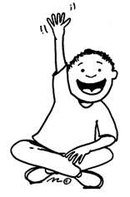  As children age and develop into adults, they gradually gain the ability to comprehend the future consequences of their actions. This is true for you in Middle school. You can guess if a good decision will lead to a positive outcome or what the consequences might be for bad decisions. In P.E. it is important to practice SELF-CONTROL. Self-control in P.E. could be sitting on your roll call number when asked, raising a hand to ask a question, or keeping your hands to yourself. During the group juggling activity, be patient, follow rules & direction, & have self-control.  We have a choice every day regarding the attitude we will embrace for that day. During activities that are difficult or challenging it is important to have PERSEVERANCE-Continuous display of determination & effort. Demonstrate how attitude, motivation, and determination are important in challenging physical activities like the “Pass Key” activity and “Poison River” activity. These activities aren’t easy but giving up is never the way to solve a problem or complete a task.  Being a leader is a big job. You are an example setter, a motivator, and a person with high expectations of themself and others. In group settings there are always leaders. Someone who takes charge, gives instruction, positive and corrective feedback, and listens to input from other students. In P.E. almost all activities are done in a group. The expectation is that you will be not only a leader but an EXEMPLARY LEADER. Think about how you will be a leader in some of the group challenges like “Toxic Waste” or “Group Skis”. Figure out the best possible way to collaborate with your team and complete the task.  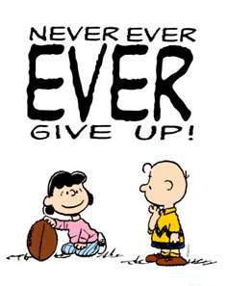  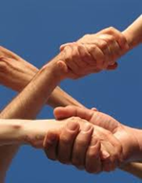  In Physical education everyone has different skill levels. Some may be an expert at an activity and some may have never even heard of some of the physical activities we will do in P.E. With that said, it is important to remember the word COMPASSION-the ability to identify with and understand somebody else's feelings or difficulties. Being compassionate in P.E. could mean not making fun of others, cheering someone on when they try a new skill, or telling them “good try”, even if they didn’t quite meet your personal ability level or expectations. Remember this as you go through the activities this week and the rest of the year. Try doing this & think of how you can set the tone in a P.E. class.  Recognize the role of cooperation and positive interactions with others when participating in physical activities today and for the rest of the year. This is known as TEAM WORK- Working together to achieve a common goal. In physical education you will do this a lot. During the “Partner get-ups” challenge activity you will do just that. When you do this activity, think about your success. Did you accomplish this task together cooperatively? Were you a positive and cooperative teammate?  The front page of this handout has bolded words throughout the text. The first letter in every word stands for an acronym (a word formed from the initials or other parts of several words) the Physical Education Department uses as our set of rules & expectations in class. It is called  THE R.E.S.P.E.C.T. MODEL  R-RESPONSIBILITY  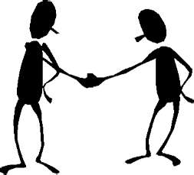  E-EFFORT  S=SELF-CONTROL  P-PERSEVERANCE  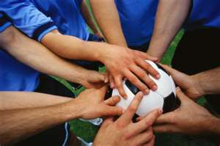  E-EXEMPLARY LEADERSHIP  C-COMPASSION  T-TEAMWORK  HOW WILL I EARN AN “A” & OUTSTANDING CITIZENSHIP IN P.E.?  Be RESONSIBLE and come to class dressed in PE attire with tennis shoes. Come out to roll call leaving all belongings locked in the locker room & sit on your number ready to learn. Have your P.E. folder & pencil with you every Friday & when your teacher says “CLASS! CLASS!”, you say “YES!, YES!”  Physical education is Physical; always give your 100% EFFORT during personal conditioning and daily skills practice. Remember, its 70% of your total grade!  There will be times you’ll want to mess around, bug or tease your friends, or use equipment inappropriately. But that will only get you into trouble. Practice SELF-CONTROL & be mature.  P.E. can be a challenge to your mind and body. Increasing fitness levels isn’t an easy task but it is rewarding once you set and reach your goals. Practice PERSEVERANCE when times get tough and you will thank yourself later.  Be the example-setter & stand out. Display EXEMPLARY LEADERSHIP by being responsible, showing effort, & perseverance.  COMPASSION is a characteristic that you can use outside of P.E. and for the rest of your life. When you are compassionate toward others you will feel good about how you treat others and how they treat you.  Demonstrate TEAMWORK to pass P.E. and earn the grade you want.  Basically, use the R.E.S.P.E.C.T. Model & you will be in great shape!

